ACRN Project Technical Community Meeting - 2018

ACRN Project TCM - 30 May 2018
Location
Attendees
Opens
Agenda
Marketing/Events
Resources

ACRN Project TCM - 30 May 2018

Location
- Online conference link: https://zoom.us/j/880368975
- Zoom Meeting ID: 880-368-975
- If Dial in: +1 877 369 0926 (Toll Free)

Attendees
Intel:
Hongbo Wang; Ren, Jack; Susie, Li; Zou, Terry; Geoffrey; David Kinder; Nianhui;...
Community:
Fang Wei (IVI, China); Ramesh (APtiv); Shouyong (ZhongKe) …

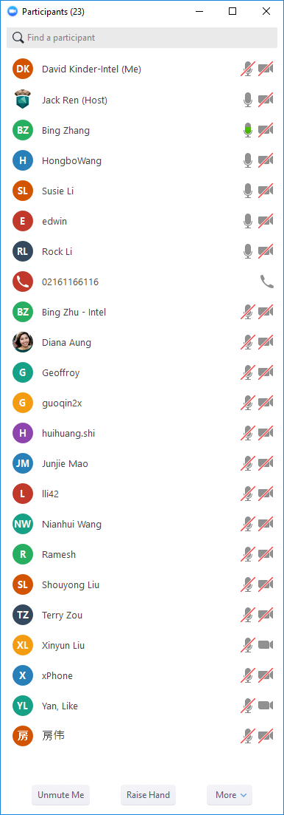
Note: If need to edit this document, please ask for access. We disabled anonymous editing to keep track of changes and identify who are the owners of the opens and agenda items.

Opens
Note: When adding opens or agenda items, please provide details (not only links), add your name next to the item you have added and specify your expectation from the TCM

Agenda
- Hongbo: Kick off Technical Community Meeting (TCM) from 5/30/2018
  - Introduce ACRN Technical Community Meeting purpose, scope.
  - Purpose:
    - Weekly technical meeting for ACRN Open Source community
    - Explore community’s interests
    - Get community’s involvement
    - Synergy on project feature, priority, bug, process
    - Drive ACRN’s execution and deliverable
  - Goal:
    - Feature development R&R
    - Resolve design opens
    - Deliver ACRN milestone release
  - Scope:
    - Roadmap breakdown and alignment
    - Key architecture discussion
    - Feature assignment
    - Close critical bugs
    - Process alignment
Attachment: https://drive.google.com/drive/folders/10ad6JQ_crUo9_yi3BoVnl07r-6qTE671?usp=sharing

Q: Is the technical steering meeting (TSC) membership free and how to join?
A: It’s free to join TSC from money P.O.V. The voting will be based on the code contribution.

- Q2’18 F2F meeting will be hosted on 6/14 in Shanghai. Welcome community developers to join and give your feedback.
  - 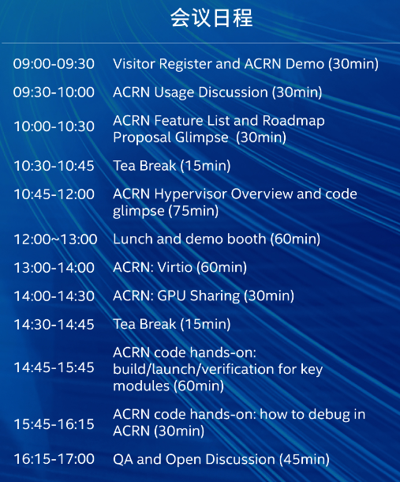
Attachment: https://drive.google.com/drive/folders/10ad6JQ_crUo9_yi3BoVnl07r-6qTE671?usp=sharing

- Jack: Go through ACRN draft roadmap
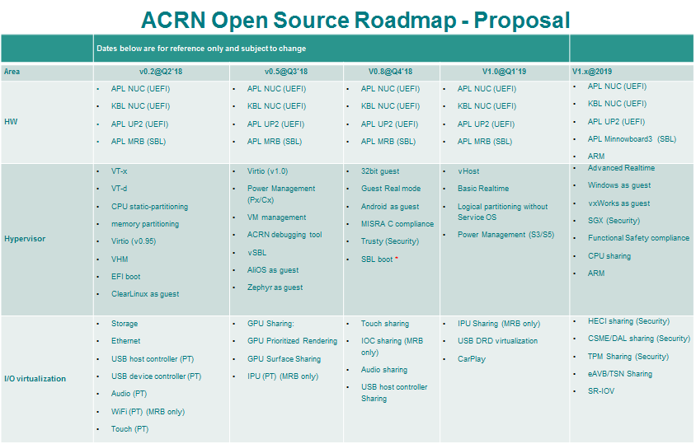

Attachment: https://drive.google.com/drive/folders/10ad6JQ_crUo9_yi3BoVnl07r-6qTE671?usp=sharing

Q: What’s recommended hardware platform for ACRN development?
A: x86 Platforms:
- Apollo Lake:
  - NUC: Intel NUC6CAYH
  - UP2 open dev kit (www.up-board.org/upsquared ):
- Kabylake (WIP):
  - NUC: NUC7i5BNH, NUC7i7DNHE

Q: How many maximum Guest VMs can ACRN support?
A: It’s limited by the hardware capability. For APL, it’s 2 VM (one SOS + one UOS); For KBL, it’ll support 4 VM.

Q: What’s the Linux distro version of ACRN’s SOS? Can it be any other Linux distro, for example, RTOS?
A: Architecturally SOS is not limited to Clear Linux, RTOS can be also working as SOS if porting RTOS to SOS. Welcome community’s porting contribution.

Q: Will ACRN be ready for AUTOSAR? (A car industry standard, https://www.autosar.org/ )
A: ACRN hypervisor itself is not AUTOSAR focused, but welcome community contribution to enable AUTOSAR compliant VMs.

- All: Community feedback collection against TCM agenda, content, etc.
Next meeting agenda proposal:
  - ACRN infrastructure introduction: document, code, issue, wiki.
  - Process discussion
  - New ACRN delta features brief
  - ACRN feature Todo list

Marketing/Events
- 1st F2F Meetup in Shanghai will be hosted on 6/14, Shanghai.

Resources
- Project URL:
  - Portal: https://projectacrn.org
  - Source code: https://github.com/projectacrn
  - email: info@projectacrn.org
  - Technical Mailist: acrn-dev@lists.projectacrn.org

